**Create a Leave Management System using Copilot**

You can easily use the options given to create your Application and have the experience of how it works. 

But here we will be creating a Leave Management System Application.

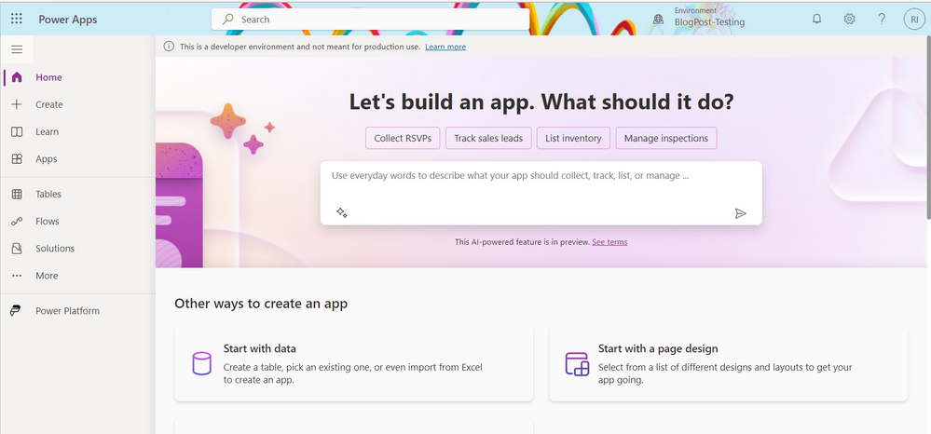

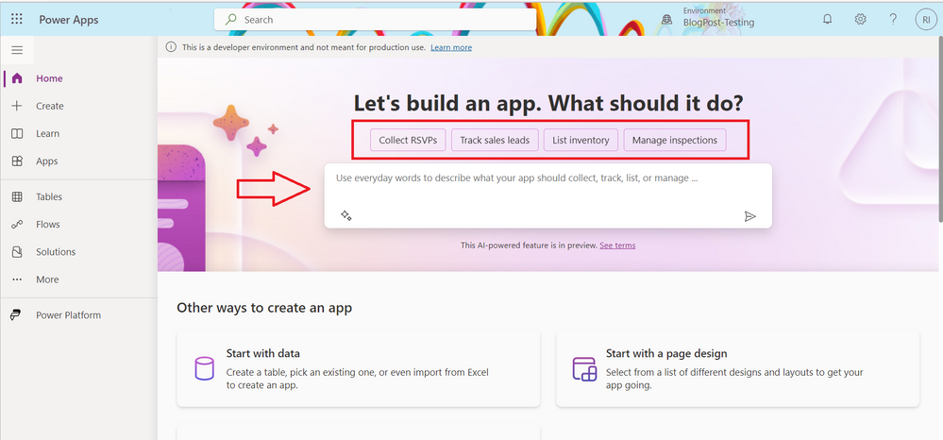

On the text boxt, enter

Leave Management System

Wait for it to load

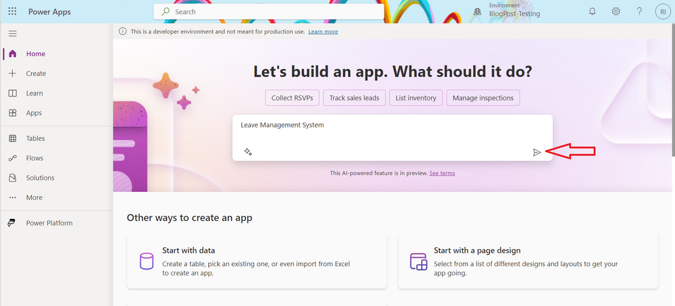

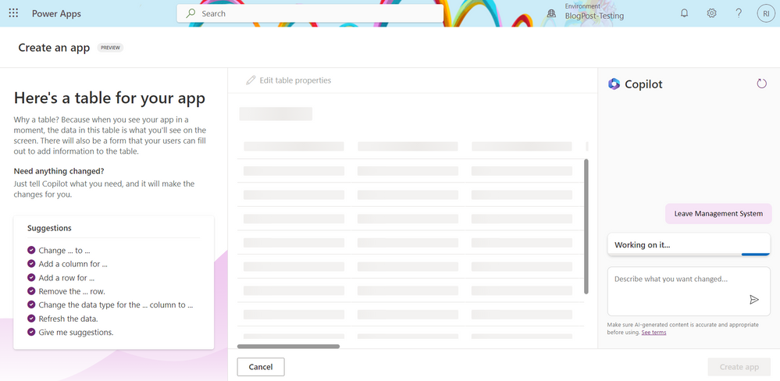

Copilot creates a Leave Management System Dataverse Table with columns and a few populated data in the columns.

Column that has been created

ID

Name

Leave Type

Start Date

End Date

Status

Reason

Comment

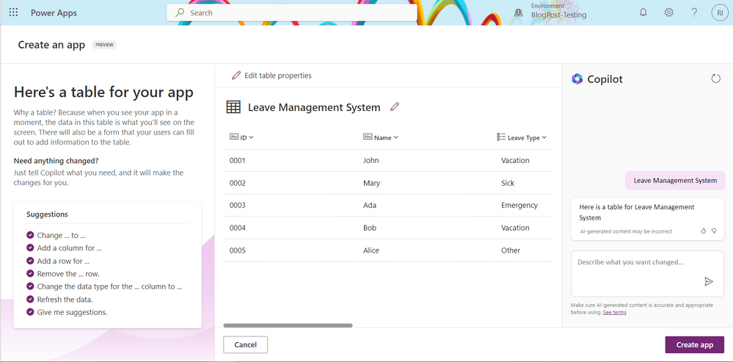

Let’s go ahead and create a new column by asking Copilot

On the chat at the right hand side, describe the column you want added to the Dataverse Table

**Add the Performance Manager Column to the Table**

Next, click on the icon

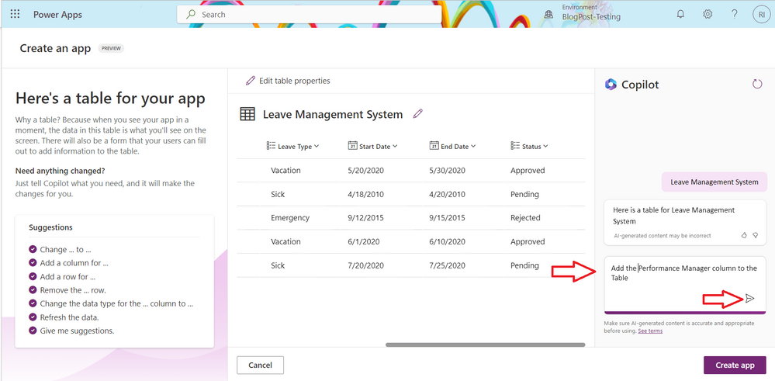

The new column, Performance Manager has been created. 

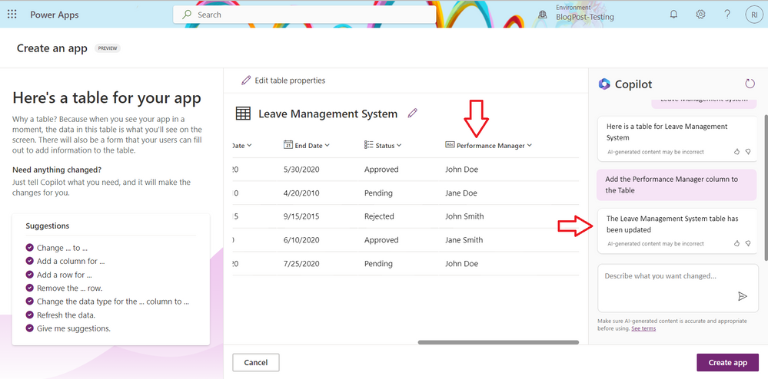

Click on Create app

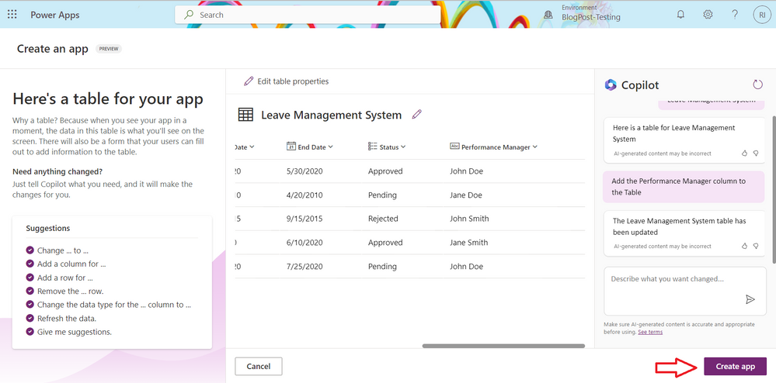

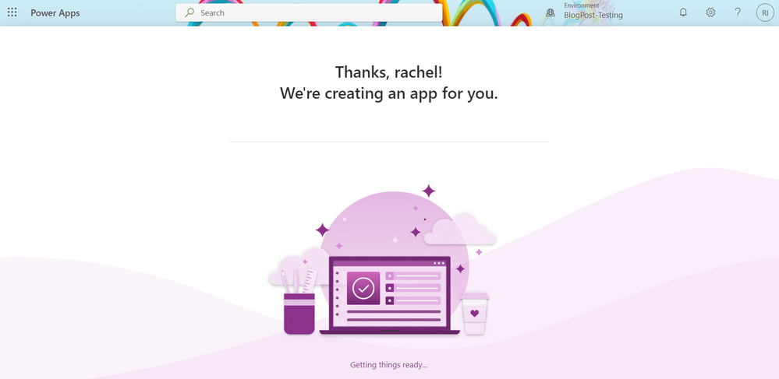

This creates a responsive Canvas apps application that has a Form and Gallery on the same screen. 



This video shows where you can enter the new data, edit the already existing data and delete the data.

